What is Prompting and how to learn?
- Prompting refers to the practice of providing specific instructions or input to an artificial intelligence (AI) model to obtain desired responses.
- In the context of AI and language models like GPT-4, prompting involves crafting queries or statements that guide the model to generate useful and relevant outputs.
Prompt Engineering is the practice of designing and refining inputs (prompts) to effectively communicate with Large Language Models (LLMs) to achieve desired outputs.
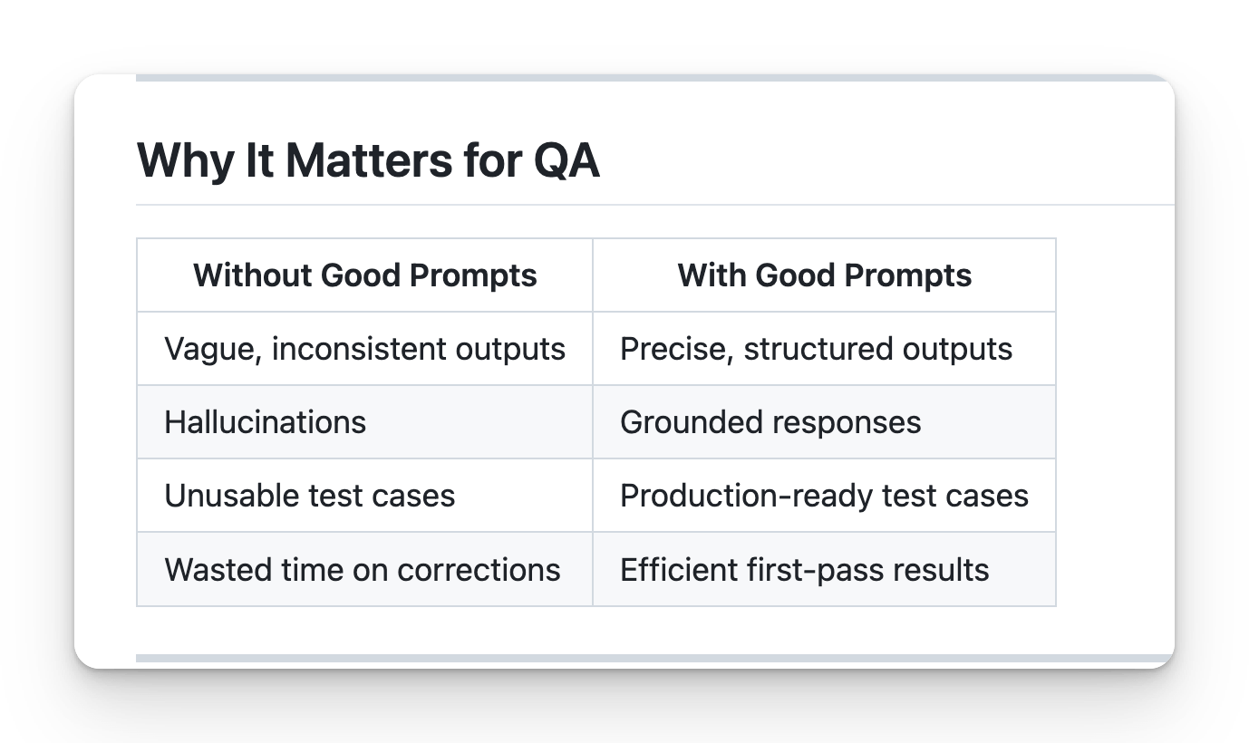
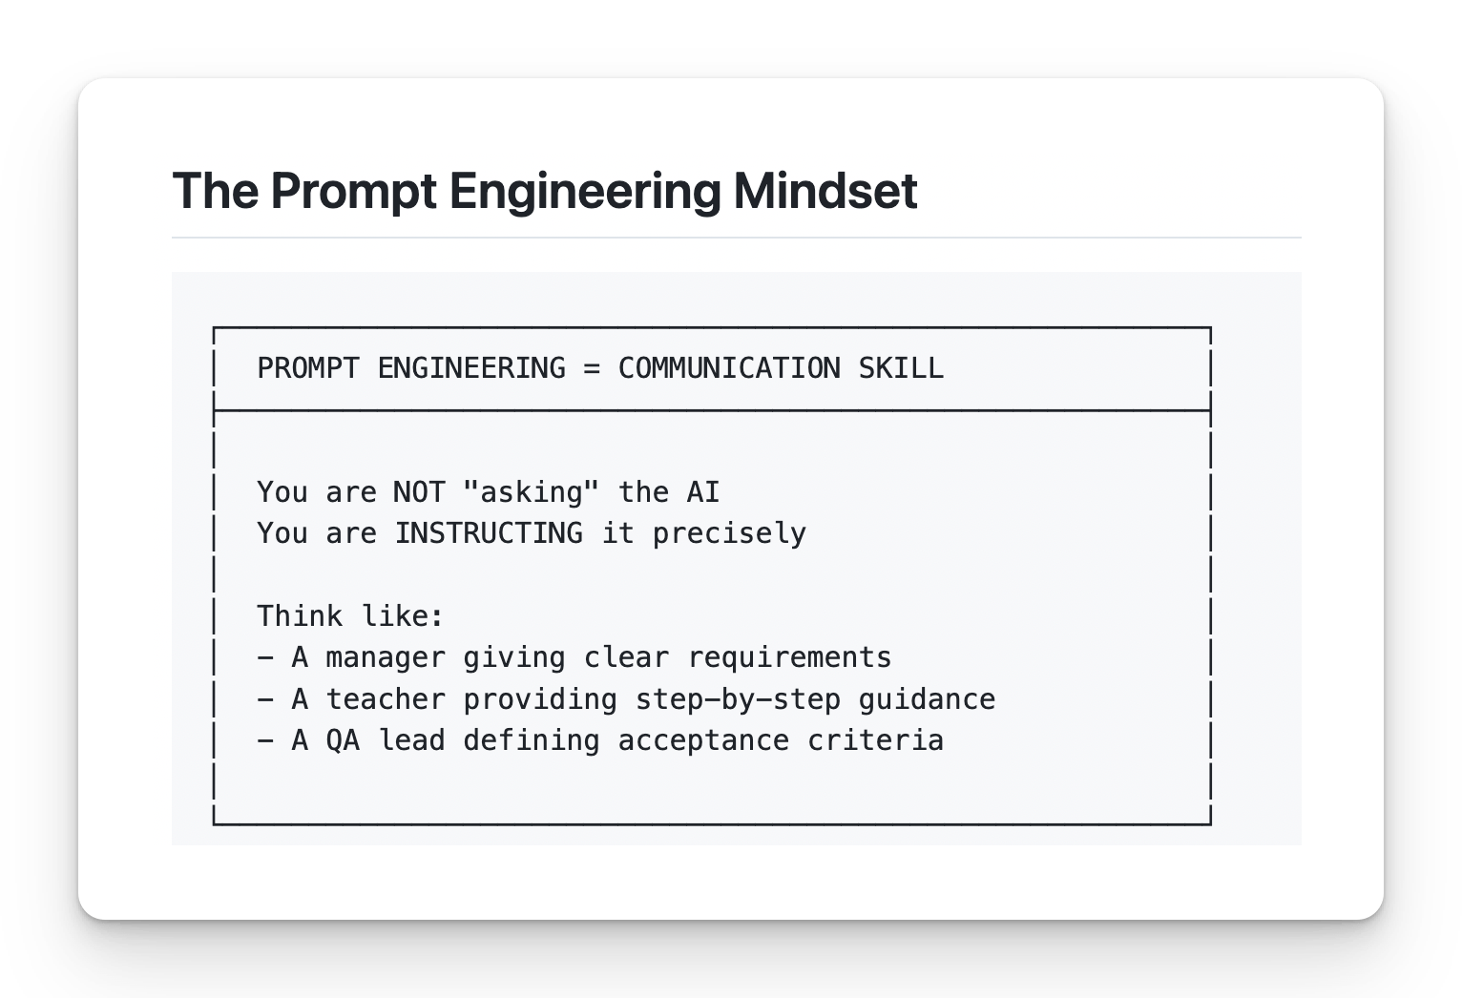
Core Principles
1. Be Specific
❌ Bad: "Write test cases for login"
✅ Good: "Write 5 functional test cases for email/password login, covering valid login, invalid email, invalid password, empty fields, and SQL injection attempt. Use the Proper JIRA format: Test ID, Description, Steps, Expected Result."
2. Provide Context
❌ Bad: "Test the API"
✅ Good: "Given this API endpoint documentation: [paste docs], write test cases covering happy path, error scenarios, and edge cases."
3. Define Output Format
❌ Bad: "Generate bug report"
✅ Good: "Generate a bug report using JIRA format: Title, Environment, Steps to Reproduce, Expected Result, Actual Result, Severity, Attachments."
4. Set Constraints
❌ Bad: "Help me test"
✅ Good: "Using ONLY the PRD provided, generate test cases. Do NOT assume any features not mentioned. If information is missing, state 'Not specified in PRD'."
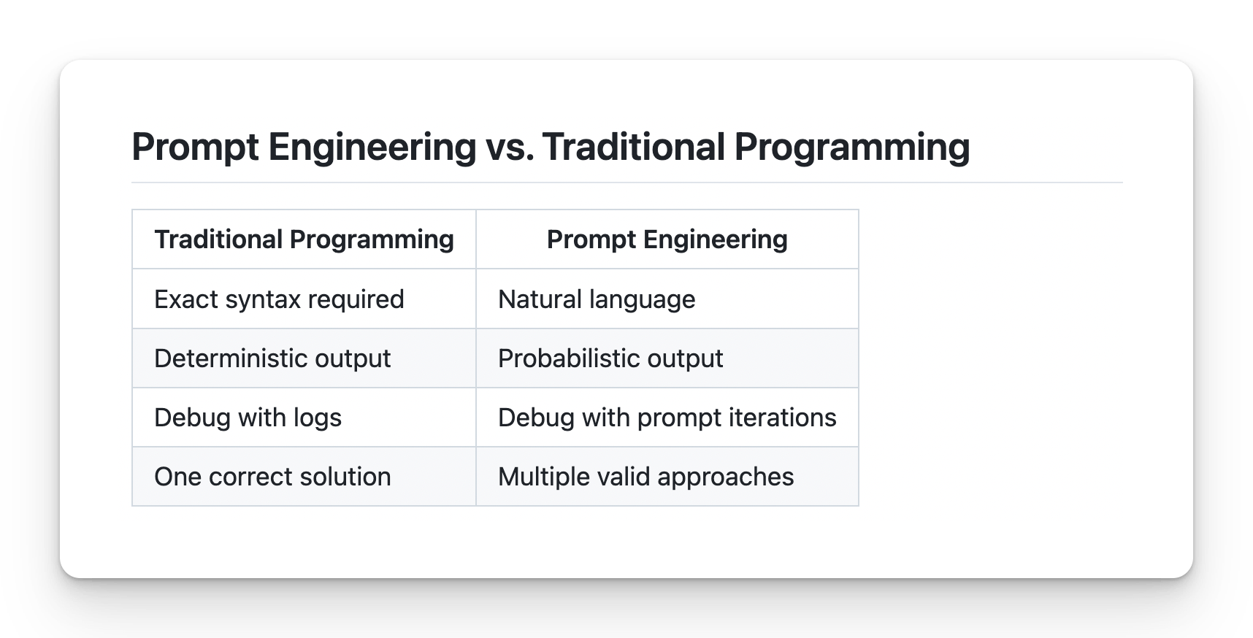
Steps to Follow for Effective Prompt Engineering
- Define the Goal │
- │ Gather Context │
- │ Choose Prompting Strategy │
- │ Structure the Prompt │
- │ Add Constraints │
- │ Test and Iterate │
- │ Document and Reuse
create testcase for app.vwo.com
Step 1: Define the Goal
Ask yourself:
- What exactly do I need?
- What will I do with the output?
- What does success look like?
❌ Vague: "Help me with testing"
✅ Clear: "Generate 10 test cases for login validation"
Step 2: Gather Context
Collect all relevant information:
- PRD / Requirements document
- API documentation
- Screenshots / UI mockups
- Error logs
- Previous test cases
- Constraints / Limitations
Rule: More context = Better output
Step 3: Choose Prompting Strategy
Situation  +  +  + | Strategy  + | +
Simple, standard task  + | Zero-Shot | No Example
Custom format needed  + | Few-Shot | 2-3 examples
Complex analysis  + | Chain-of-Thought | Ask him to think about it
Domain expertise needed  + | Role-Based | Act as QA
Step 4: Structure the Prompt
Use a framework (RICE POT recommended):
ROLE: [Expertise]
Instructions: [Purpose]
CONTEXT: [Background info]
EXPECTED: [Success criteria]
PARAMETERS: [Constraints]
OUTPUT: [Format]
TASK: [Specific instruction]
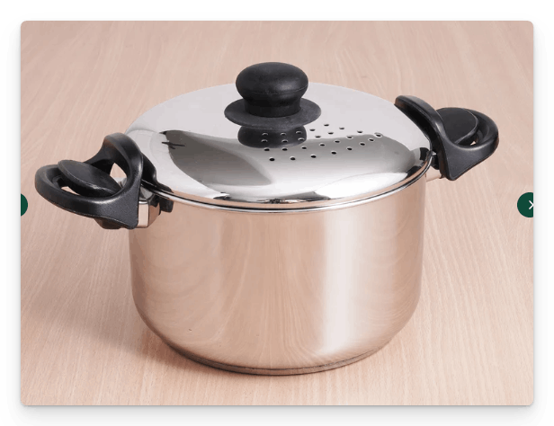
Task : Write a Selenium Code for the Sales Force login ﻿login.salesforce.com/?locale=in
Role : you are a QA automation tester with 15 years of experience. You have a very good understanding of IT, CRM projects like salesforce.com. You need to create a framework with Selenium, Java, Maven, TestNG, and it should be enterprise-level framework that we need to create.
I - Instructions
- Generate a Complete Selenium with Java automation script following the standard of enterprise level standards.
- Automate and verify the results of the login page ﻿login.salesforce.com/?locale=in, ensure that UI is thoroughly tested with valid and invalid testcases.
- [Critical] - Apply the TestNG annotations, @Test, @BeforeTest and others and and necessary setup/teardown logic.
- [Critical] Implement robust exception handling within both Page Object model and test scripts using structured try–catch blocks or explicit exception signatures.
- [Mandatory] Use Page Object Model with PageFactory, including @FindBy, constructor initialization, and reusable action methods.
- [Mandatory] - It is important that you use only the xpath not the css selectors.
- [Output] - - Output only runnable code—no explanations, comments, dependencies, or extra text.
- [Don't] - Don't use the css selectors, ID, name and others things.
- [Don't] - Don't add comments, Thread.sleep and other bad coding practice.
- [Generate] - Generate the 2 scritps only with the valid and invalid testcases of the login page.
- [DoNOTuse] Thread.sleep() anywhere; rely on WebDriverWait or implicit waits.
- Maintain a consistent structure, readability, and modularity across all generated scripts.
C — Context You are creating a login page scripts with proper framework for the sales force login, which is a AB Testing website with valid and invalid login page where in the login page you have the email, password and submit buttin with remember me fucntionality.
E — Example Example structure for PageFactory:
public class LoginPage { @FindBy(xpath = "//input[@id='username']") WebElement username;
@FindBy(xpath = "//input[@id='password']") WebElement password; @FindBy(xpath = "//input[@id='Login']") WebElement loginButton; public LoginPage(WebDriver driver) { PageFactory.initElements(driver, this); } public void doLogin(String user, String pass) { username.sendKeys(user); password.sendKeys(pass); loginButton.click(); }
P — PARAMETERS with production level automation script expert with pin point accuracy and almost zero bad coding practice.
O — Output Provide only:
- 1 Page Object file
- 2 TestNG test scripts
- Maven project No explanations or additional content.
T — Tone Technical, precisly, enterprise-grade, code-one.
﻿github.com/PramodDutta/AI-Tester-Blueprint/blob/main/chapter_02_prompt_engineering/core_concepts/RICE_POT_pe.md

01/Feb/2026
Quick Checklist for Good Prompt
- Goal is clearly defined
- All relevant context is included
- Appropriate strategy chosen
- Prompt is well-structured
- Anti-hallucination constraints added
- Output format specified
- Task instruction is specific

Common Mistakes to Avoid
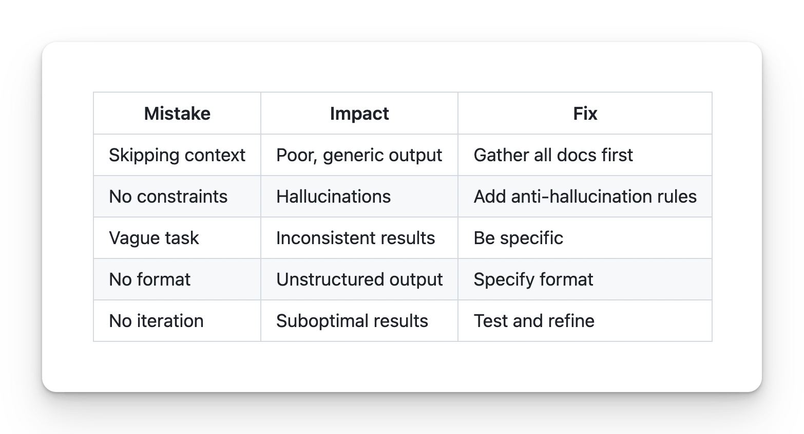
Prompt Frameworks: STAR, CLEAR, CRISP
🧠 Types of Prompts
Direct Prompts: Explicitly stating what you want the AI to do.
Example: "Write a summary of the book '1984' by George Orwell."
Contextual Prompts: Providing background information or context.
Example: "In George Orwell's dystopian novel '1984', the protagonist Winston Smith..."
Step-by-Step Prompts: Breaking down the task into smaller steps.
Example: "First, list the ingredients for a chocolate cake. Then, describe the baking process."
Role-Based Prompts: Asking the AI to assume a specific role or perspective.
Example: "As a software engineer, explain the concept of polymorphism."

1. CRAP / CRISP Framework
C — Context R — Role A — Action
I - Instructions P — Parameters (optional)
﻿chatgpt.com/share/692f98ea-86d8-8009-905a-e7f2ae5d8e9a
﻿claude.ai/share/5c25bfd8-30d8-400e-a691-3edd01483ea1
﻿www.kimi.com/share/19c17db0-3082-80f3-8000-0000c579c4cb

2. RACE
R — Role A — Action C — Context E — Expectation
R — Role A — Action C — Context E — Expectation Task - Bug Report for the invalid login at the app.vwo.com
﻿https://www.kimi.com/share/19c17e4e-65f2-8f09-8000-00001caefd1b﻿﻿

3. COAST
C — Context O — Objective A — Action S — Style T — Tone
4. CLASSIC “Role Model Prompting”
“You are X, behave like Y, produce Z.” Feels like assigning an actor their script 🎭.
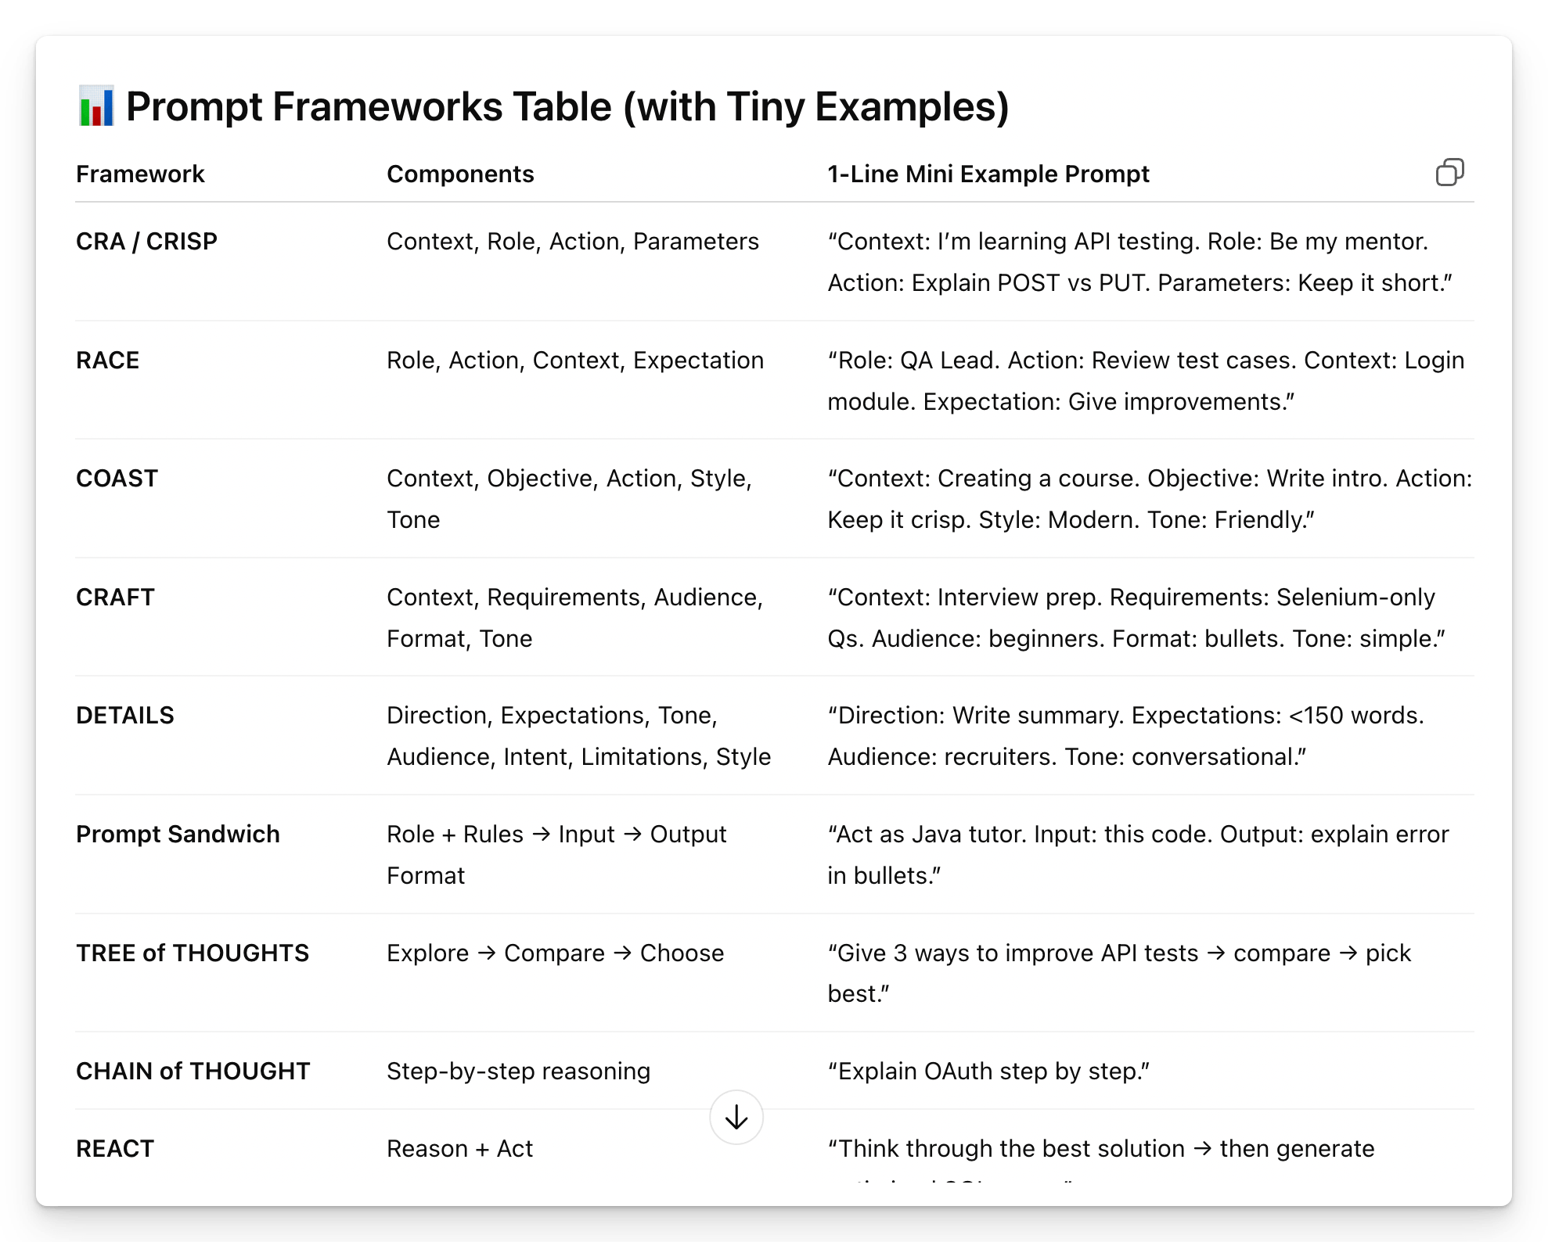
STAR — Situation-Task-Action-Result
Often used in behavioral interview contexts.
Formula: Describe [Situation], outline the [Task] taken, and share the [Result.
Example: In a declining market [Situation], my task is to maintain sales volume [Task]. What are the possible initiatives [Actions], to retain the majority of our customers base
STAR Framework
Origin: Adapted from behavioral interview technique
┌─────────────────────────────────────────────────────────┐
│ STAR FRAMEWORK │
├─────────────────────────────────────────────────────────┤
│ S - Situation │ Background and context │
│ T - Task │ What needs to be done │
│ A - Action │ How to approach it │
│ R - Result │ Expected outcome │
└─────────────────────────────────────────────────────────┘
CLEAR — Challenge-Limitation-Effect-Action-Result
This is used to identify challenges, explain limitations, suggest possible actions, and anticipate future outcomes. Formula: Identify a [challenge], acknowledge a [Limitation], predict the [Effect], propose an [Action], and envisage the [Result]. Example: The challenge of declining user engagement [Challenge], limited by our current platform capabilities [Limitation], leads to lower retention [Effect], what upgrades to our platform [Action] will increase engagement [Result].
PAR — Problem-Action-Result
Often used in behavioral interview contexts but focuses on problem-solving scenarios.
Formula: State the [Problem], describe the [Action] taken, and reveal the [Result]
Example: Facing the problem of high employee attrition [Problem], how to introduce an employee engagement program [Action], to increase retention quickly [Result]

Standard Way to Create the Test Plan
﻿claude.ai/share/27c0068e-cecf-4b4d-8ec0-0b63957db95d

RICE POT = Role + Intent /Instruction + Context + Expected + Persona + Output + Task
STAR = Situation + Task + Action + Result
CLEAR = Context + Language + Examples + Audience + Result
CRISP = Context + Request + Input + Scope + Parameters

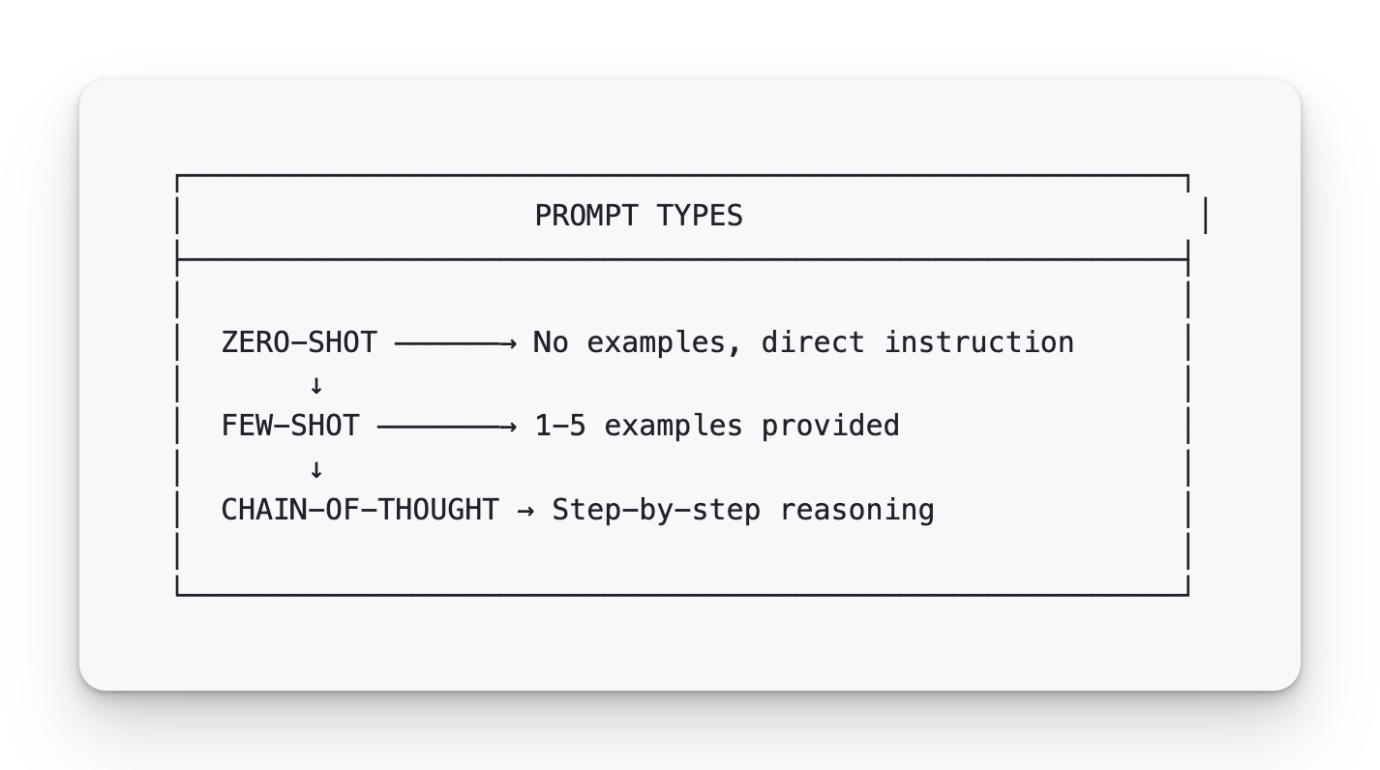
Zero-Shot Prompting
Write 3 test cases for a login page with email and password fields. Format: Test ID, Description, Steps, Expected Result
Few-Shot Prompting
Generate test cases following this example:

EXAMPLE:
TC_001 | Valid Login | Enter valid email and password | User redirected to dashboard

NOW GENERATE:
3 more test cases for invalid login scenarios.
Chain-of-Thought (CoT)
Definition: Asking the model to reason step-by-step.
When to use:
- Complex analysis
- Multi-step problems
- When reasoning matters
Analyze this bug report step by step:

Step 1: Identify the reported symptoms
Step 2: List possible root causes
Step 3: Determine what information is missing
Step 4: Suggest next debugging steps

Bug Report: "Checkout fails intermittently on mobile"
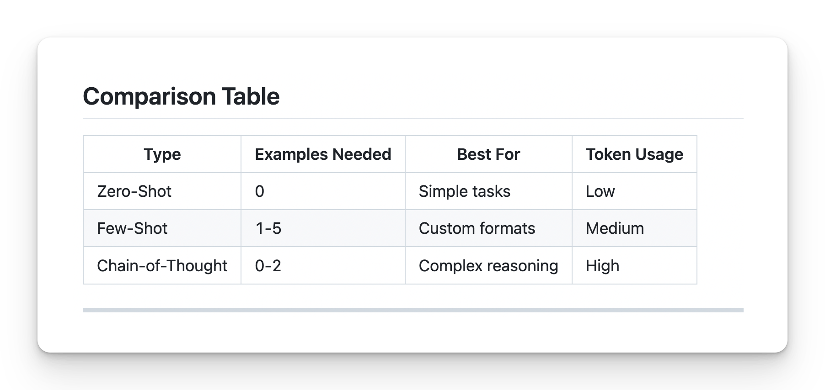
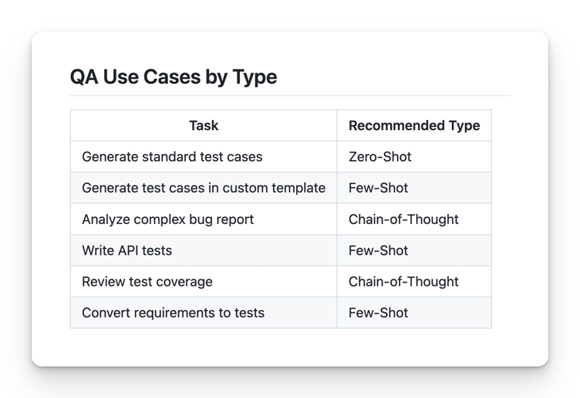

Advanced: Combining Types
For best results, combine techniques:
ROLE: Senior QA Engineer

TASK: Analyze this PRD and generate test cases.

CHAIN-OF-THOUGHT:
1. First, extract all testable requirements
2. Then, identify edge cases
3. Finally, generate test cases

FEW-SHOT EXAMPLE:
| TC_001 | Requirement: User login | Steps: Enter credentials | Expected: Dashboard shown |

CONSTRAINTS:
- Use ONLY PRD content
- Mark assumptions explicitly

PRD:
[paste PRD]

Checklist: Is Your Prompt Complete?
- Role defined
- Context provided
- Task is specific and quantified
- Constraints prevent hallucinations
- Output format specified
- Terminology defined if needed
https://www.kimi.com/share/19c180b4-0852-881c-8000-0000469b250b
﻿chatgpt.com/share/697efcef-7c50-8009-b5e6-db0a4fab6f82

